

Mobile Platform Development Report

| Student Name | Student ID | Student E-mail |
| --- | --- | --- |
| Margaret Maina | s1906597 | MMAINA200@caledonian.ac.uk |

Student Declaration: This piece of work is not plagiarized. It is my own original work and has not been submitted elsewhere in fulfillment of the requirements of this or any other award.

Signature: *Margaret Maina*  Date: *16th April 2022*

# Table Of Contents

**Table Of Contents** **2**

**Links** **3**

**Introduction & Background** **4**

Introduction 4

Application Testing 5

Test Reports 5

Test Screenshots 7

# 

# Links

# 

# 

<https://github.com/CaptanoMaina/England_Incidents>

# 

# Introduction & Background

## Introduction

This coursework focuses on parsing an rss feed as appropriate reports to show the current incidents, roadworks and planned roadworks from the National highways UK xml feed. The target device is a mobile computing device running Android 6.0 (Marshmallow) or later. The ide used for the development of the application is Android Studio and the application is written in Java/XML.

## 

## 

## 

## Application Testing

## 

## Test Reports

The following unit and system tests were performed on the BetaFit application.

| **Test Scenario** | **Expected Result** | **Actual Result** | Status |
| --- | --- | --- | --- |
| Displaying core roadwork incident details with the option to display more detailed road work/planned roadwork information when an item is selected from the displayed list. | The roadwork information is displayed | The roadwork information is displayed | PASSED  Refer to Figure 1 |
| The user can enter a specific date and the app should display a list of the Current Incidents/Roadworks/Planned Roadworks for that day | Current Incidents/Roadworks/Planned Roadworks for that day are displayed | Current Incidents/Roadworks/Planned Roadworks for that day are displayed | PASSED |
| The user can locate the event on a google map | Event is loaded on a google map | Event is seen on google map | PASSED  Refer to figure 3 |
| A user can create a journey planner to view any roadworks for the date of the planned journey | A journey planner is created | A journey planner is created | PASSED |
| The displayed list uses some form of color representation to represent the length of time that a particular set of road works will be in place. | The displayed list uses some form of color representation to represent the length of time that a particular set of road works will be in place | The displayed list uses some form of color representation to represent the length of time that a particular set of road works will be in place | PASSED  Refer to figure 2 |
| The application has a portrait view | Information is viewed in portrait view | Information is viewed in portrait view | PASSED  Refer to figure 1 |
| The application has a landscape view | Information is viewed in landscape view | Information is viewed in landscape view | PASSED  Refer to figure 4 |

### 

## Test Screenshots

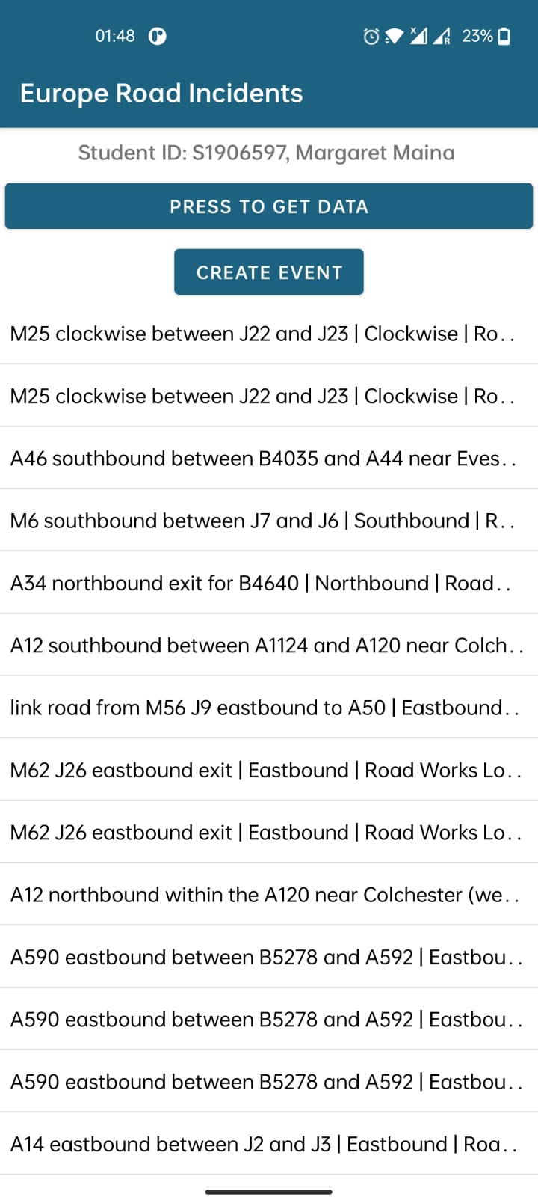

**Figure 1**

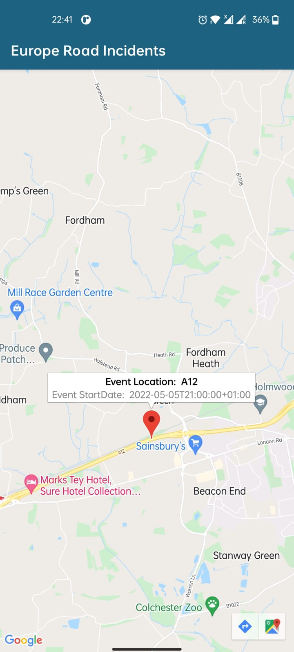

**Figure 2**

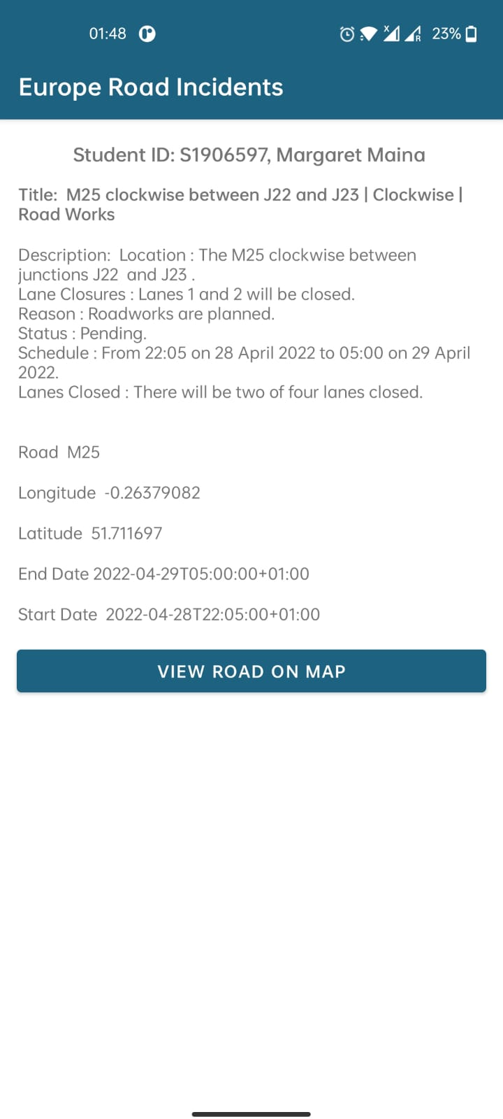

**Figure 3**

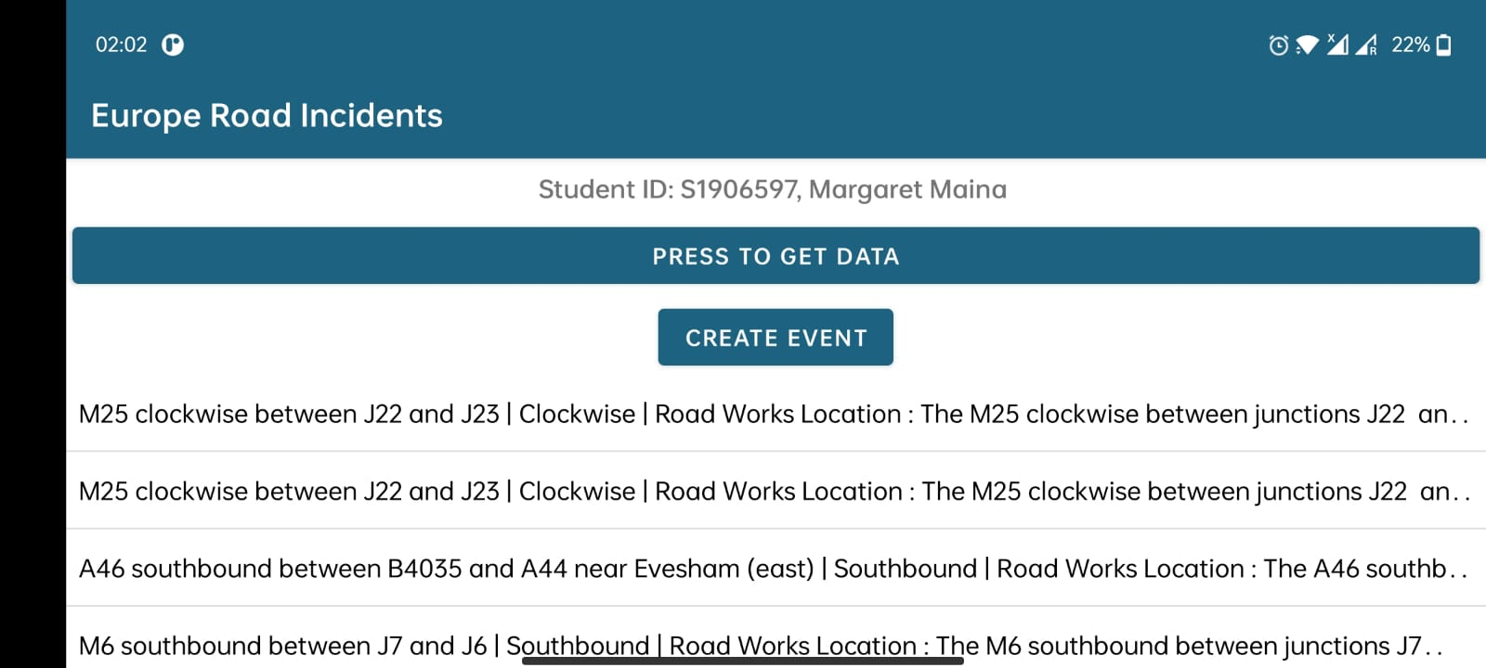

**Figure 4**

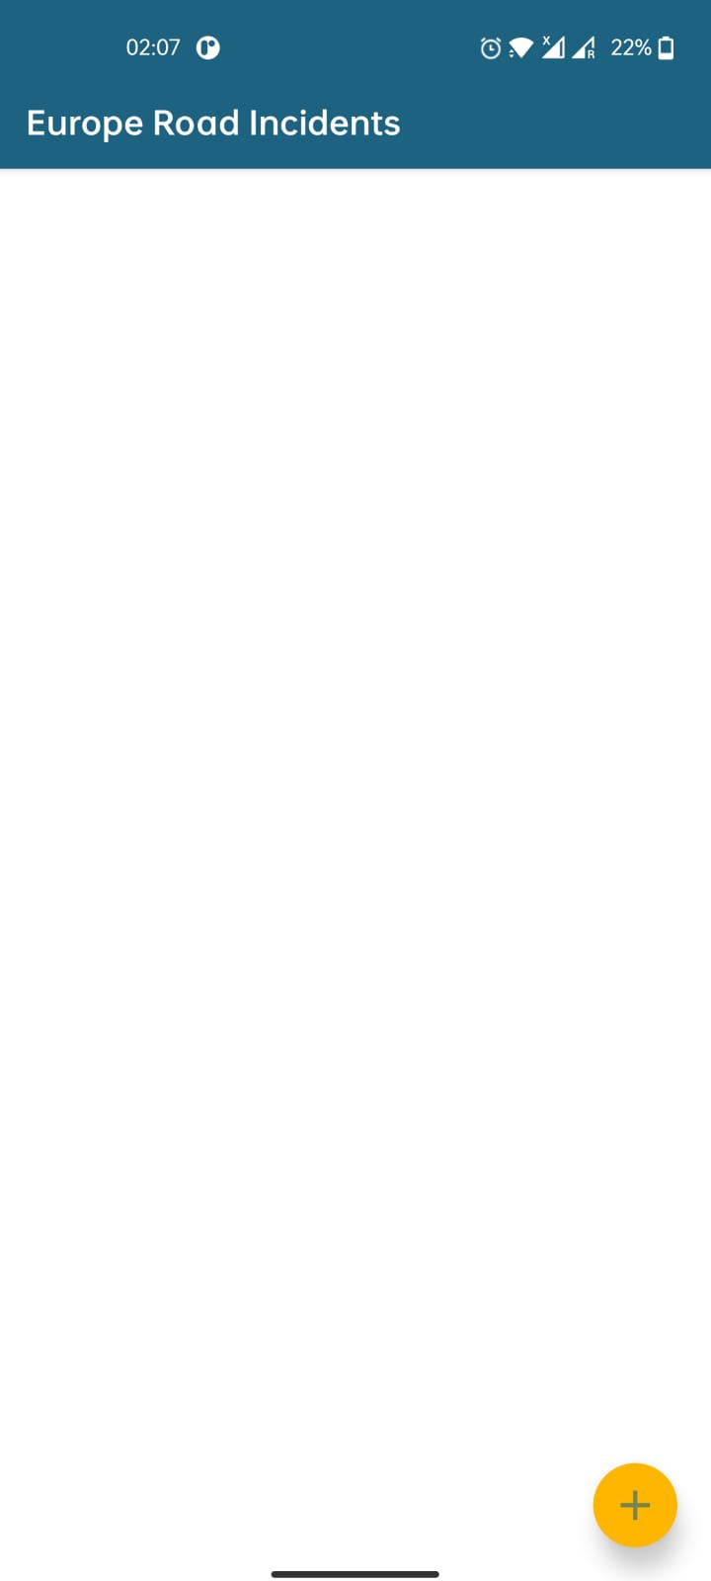

**Figure 5**